Interactive WebAssembly and WASM Standalone in Blazor

1. Conceptual Overview
Interactive WebAssembly (Blazor Web App model)
- Introduced with .NET 8+ Blazor Web Apps
- WebAssembly runs in the browser
- The app is hosted by ASP.NET Core
- Uses render modes (InteractiveWebAssembly)
- Supports hybrid rendering (SSR → WebAssembly)
WASM Standalone (Classic Blazor WASM)
- Introduced in Blazor WebAssembly (pre-.NET 8)
- Runs entirely in the browser
- No server-side UI hosting
- Pure Single Page Application (SPA) model

2. Hosting Model
Aspect | Interactive WebAssembly | WASM Standalone
Server Required | Yes (ASP.NET Core) | No
Hosting Location | Server + Browser | Browser only
Deployment | ASP.NET Core app | Static files (CDN/IIS/S3)

3. Rendering Pipeline
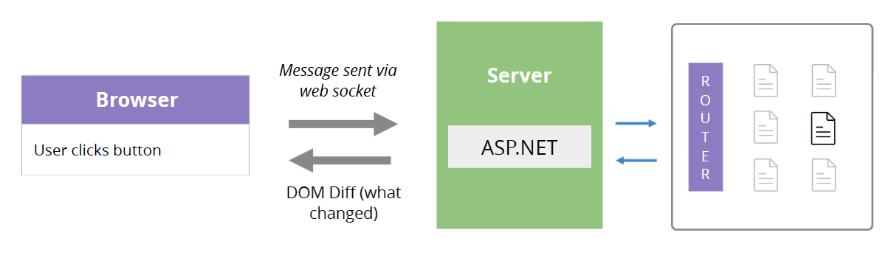
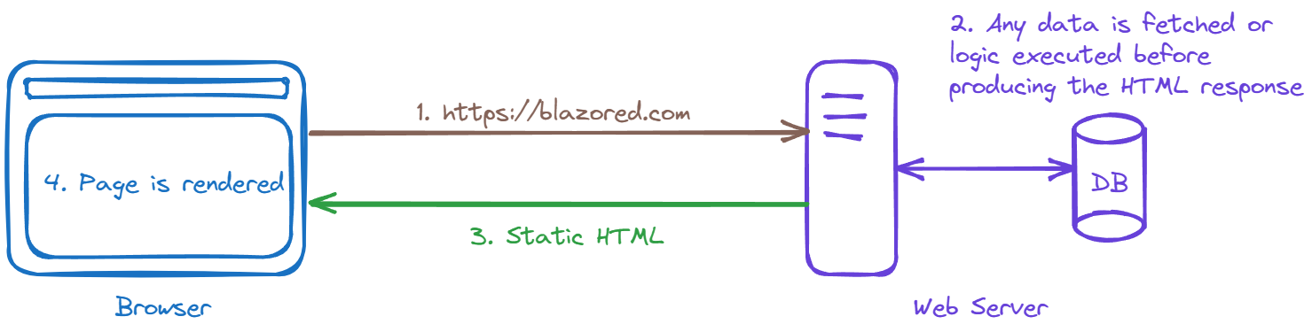

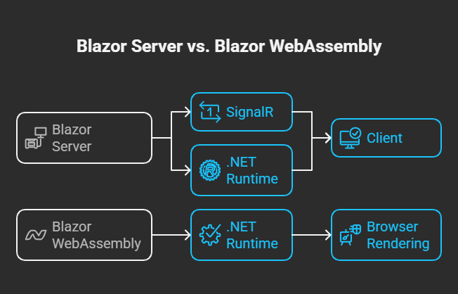
Interactive WebAssembly
- Page is server-side rendered (SSR)
- HTML is sent immediately to browser
- WebAssembly loads in background
- App becomes fully interactive
WASM Standalone
- Browser downloads:
  - .NET runtime
  - DLLs
  - App assemblies
- App renders only after download completes
- No SSR

4. Performance & User Experience
Feature | Interactive WebAssembly | WASM Standalone
First Load | Faster (SSR) | Slower
Perceived Speed | High | Medium
SEO | Excellent | Poor
Offline Support | Limited | Excellent
Cold Start | Minimal | High

5. Code Structure Differences
Interactive WebAssembly
@rendermode InteractiveWebAssembly
- Components can:
  - Start as SSR
  - Become interactive later
- Can mix:
  - Static pages
  - Interactive WASM
  - Interactive Server

WASM Standalone
<Router AppAssembly="@typeof(App).Assembly">
- Entire app is client-only
- No render modes
- No SSR

6. API & Security Model
Aspect | Interactive WebAssembly | WASM Standalone
API Calls | Can be server-local | Must be HTTP
Authentication | Server-based auth possible | Token/JWT only
Secrets | Can stay on server | Must be public-safe

7. Progressive Web App (PWA)
Feature | Interactive WASM | WASM Standalone
PWA Support | Partial | Full
Offline Mode | Weak | Strong
Background Sync | Limited | Supported
Push Notifications | Supported | Supported
Note: For offline-first apps, WASM Standalone is superior.

8. When to Use Which?
Choose Interactive WebAssembly when:
- You want fast initial load
- SEO matters
- You want server + client hybrid
- You are building enterprise apps
- You want shared auth, logging, DI
Choose WASM Standalone when:
- You need offline-first
- You want static hosting
- You are building a PWA
- You want zero server dependency
- You want CDN-scale deployment

9. Summary Comparison Table
Dimension | Interactive WebAssembly | WASM Standalone
Rendering | SSR → WASM | Client-only
Server Dependency | Required | Not required
SEO | Excellent | Poor
Offline Support | Limited | Strong
Hosting | ASP.NET Core | Static files
Complexity | Higher | Lower
Best For | Enterprise, SEO apps | PWAs, offline apps

10. One-Line Definition
- Interactive WebAssembly:
A server-hosted Blazor app that becomes interactive using WebAssembly.
- WASM Standalone:
A pure client-side Blazor SPA running entirely in the browser.

